|  |
| --- |
| Mac/Windows |
| Open Presentation |
| Project setup document |

|  |
| --- |
| Shamaila Mahmood  6/23/2015 |

Contents

Project setup steps 3

Step1: Nodejs 3

Step 2: Source Tree 4

Step 3: Install Git 4

Step 4: Clone repo 4

Step 5: Bower 5

Step 6: Grunt 5

Step 7: Bower update 6

Step 8: Xampp 6

Step 9: Xampp Configuration 6

Step 10: Run server 7

Step 11: Run application 7

# Project setup steps

## Step1: Nodejs

Download and Install nodejs from nodejs.org.

https://nodejs.org/download/

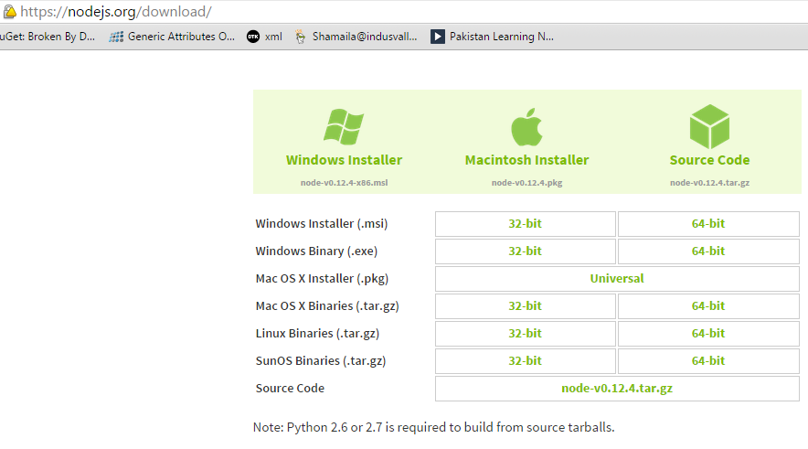

To test your installation enter following command on command prompt

node -v

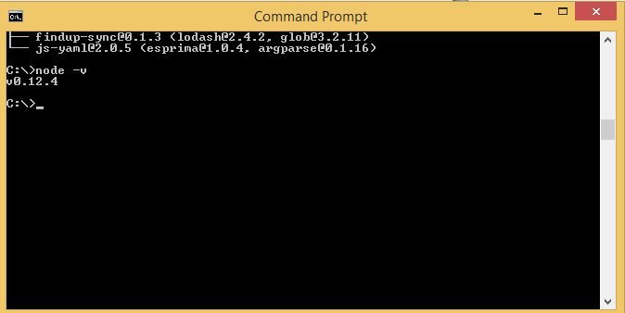

## Step 2: Source Tree

Download and install SourceTree.

https://www.sourcetreeapp.com/download/

## Step 3: Install Git

Download and install GIT for windows.

https://msysgit.github.io/

## Step 4: Clone repo

Clone github repository.

https://github.com/swardi/OpenPresentation

Follow the instructions and fetch code.

After fetching code you will have something like the following screen shot shows.

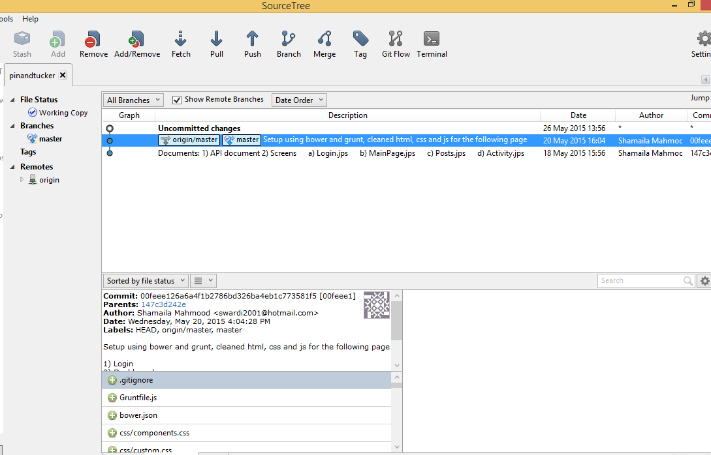

## Step 5: Bower

Run following command on command prompt

npm install -g bower

It will install bower globally.

## Step 6: Grunt

Run following command on command prompt

npm install -g grunt

It will install grunt on your machine.

## Step 7: Bower update

In the command prompt go to your project folder and run following command.

Bower Install

It will download all dependencies and create a new folder called bower_components in the project folder.

## Step 8: Xampp

Download and install Xampp

https://www.apachefriends.org/download.html

## Step 9: Xampp Configuration

Change httpd.conf file and add your project folder as document root.

Example:

DocumentRoot "C:/dev"

<Directory "C:/dev">

Options Indexes FollowSymLinks Includes ExecCGI  
 AllowOverride All  
 Require all granted

</Directory>

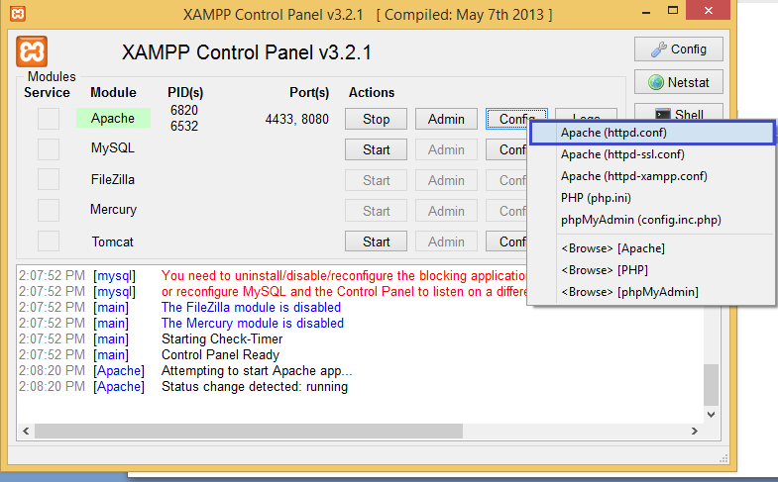

## Step 10: Run server

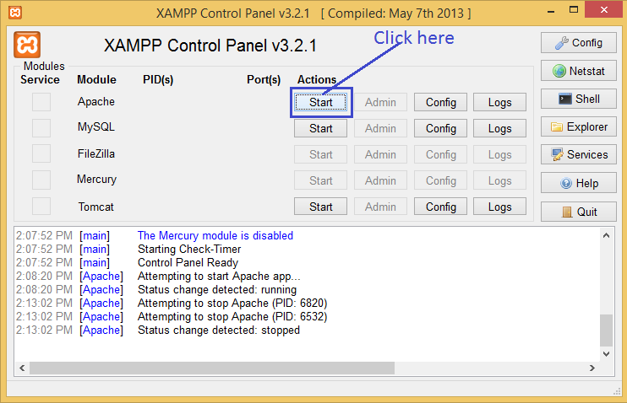

## Step 11: Run application

Open your browser and enter the url of application.

http://localhost:8080/OpenPresentation/